**

**Table of Contents**

1. **Project Description**
2. Summary

**II. Characters**

**A.** Derek Carter

**B.** Aliens

**III.** **Theme**

1. Theme

**IV.** **Gameplay**

1. Player Goals
2. Player Challenges
3. Player Skills

**V.** **Game Mechanics**

1. How They Work

**VI.** **Items**

1. Handgun
2. Steak Knife
3. Machete
4. Baseball bat

**VII.** **Progression**

1. Level Design
2. Player Win/ Loss

**VIII.** **Art Style**

1. Concept of the Art

**IX.** **Music & Sound**

1. Music
2. Sound FX

**X.** **Technical Description**

1. Tech Used
2. Platforms
3. Controls
4. **Project Description**
5. **Summary**

We are creating an action game that immerses players into a unique three-dimensional environment. Per work guidelines this game will be in a third-person view. The main goal that we are trying to capture the look and feel of other past games and create something new from it. We have borrowed influences from Doom, Duke Nukem, Alien, and several other nineties action games. Any game that you can think that has action and violence has some influence on our project. With several weapons that you can obtain, you have a chance at being unstoppable.

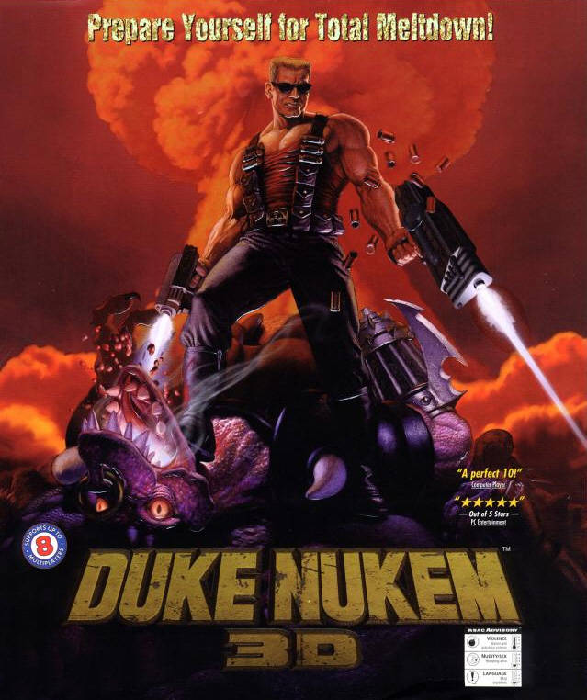

**II. Characters**

1. The main character is named Derek Carter. He is a racially ambiguous gang member from California. He is a violent member of a street gang called the Scorpion Coalition. A man of average height and average intelligence he always keeps a handgun on him in case a rival wants to try something. He is also in charge of the recruitment process. The Scorpion Coalition is a gang that gets its main revenue from drug deals around the local Richmond area. His life takes a turn for the worse when he wakes up in a hotel and discovers that aliens are attempting to take over the world. His clothing design borrows influence from the main gang in Warriors’ movie

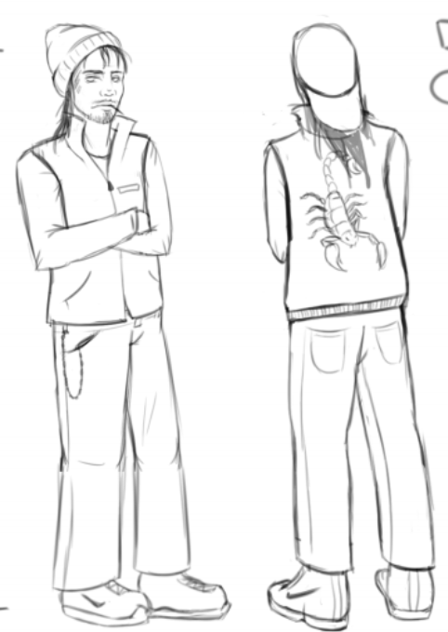

1. The aliens are the main antagonists of the game. They take on monstrous forms and will do anything to take the player out. The mother alien is the final boss for the game and once you defeat her all is revealed to the main player. There are other minor characters towards the ending, but they do not have an impact on the gameplay and are used to bring the story together.

**III.** **Theme**

1. For this game we will combine the hip hop/gang culture of the early eighties with science fiction elements. The leading character is your archetypical gang member and his clothes and weapons are inspired by the hip hop lifestyle. The science fiction part comes from the aliens and the designs of their weapons and the main spaceship that shows up at the end of the game. We wanted to truly evoke the nostalgia from the eighties with this game. When playing this game, we want people to think of movies like Colors, Boyz n the Hood, Aliens and other films of the nineties.

**IV.** **Gameplay**

1. The player’s goal is to survive the alien hoard through each three levels. Reaching the end of the third level wins the game. The player then makes a discovery that their acts of heroism were in fact acts of horrible violence on innocent people.
2. Some challenges the player will face are fast and vicious UI enemies. Choosing the correct weapon for combat.
3. The player will be able to walk, run, jump, shoot and perform melee attacks to try and survive the alien onslaught.

**V.** **Game Mechanics**

1. Health bar. You begin with 100% health and as you are attacked your health

depletes. If your health bar reaches 0% before the end of the game, you will die

and restart from level 1.

**B.** Melee attacks like punch, kick and slams.

**C.** Shooting. Requires player to aim weapon using mouse and fire using left mouse

click.

**VI.** **Items**

Items are scattered around each of the levels. You always start the game off with the

Handgun while the rest of weapons must be obtained.

1. Handgun

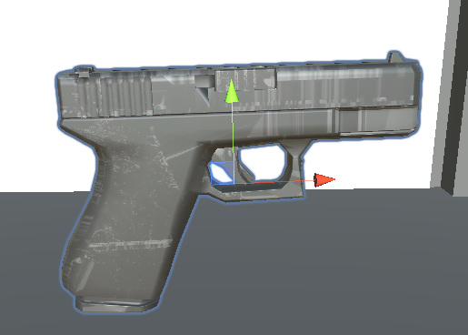

1. Steak Knife
2. Machete
3. Baseball bat

**VII.** **Progression**

1. Level Design

The game contains four levels. The first level is a quick tutorial that takes place at an urban warehouse. The next level takes place in a rundown motel and is the start of the actual game. The player must reach outside without being killed by the aliens to advance to the next level. The next level is urban San Francisco. The player must make their way down the street and reach the Space Ship while avoiding the aliens to make it to the final level. Once in the final level the player must defeat the “boss”. Once the boss is defeated the player discovers the truth behind their actions and everything is finally revealed.

1. Player win/loss

Player wins by successfully getting through all three levels without dying as killing the aliens is not mandatory for level progression. If the player dies before the end of the third level, they will restart at level 1 each time.

**VIII.** **Art Style**

1. Art for this game was inspired by urban San Francisco and other California cities in the 1980’s with a mix of futuristic color schemes for some scenes. There is a mix of neon bright colors with dark natural earthy tones of the inner city.

**IX.** **Music & Sound**

1. Music

Hip hop and/or rock beats

1. Sound FX

Gun firing, footsteps, explosions, player groans, enemy groans, spaceship noises. Player hitting ground.

**X.** **Technical Description**

1. Tech Used

We used Unity for our game engine, Maya for our models as well as photoshop and in design.

1. Platforms

This game is made for Windows OS.

1. Controls.

W - move forward

A - move left

S - move back

D - move right

Shift + W - sprint forward

Space bar - jump

Mouse - look around

Mouse left click - use weapon

Mouse right click - switch weapons.

Enter - pick up/drop item

Esc - open pause menu

The arrow keys can also be used to control the player.